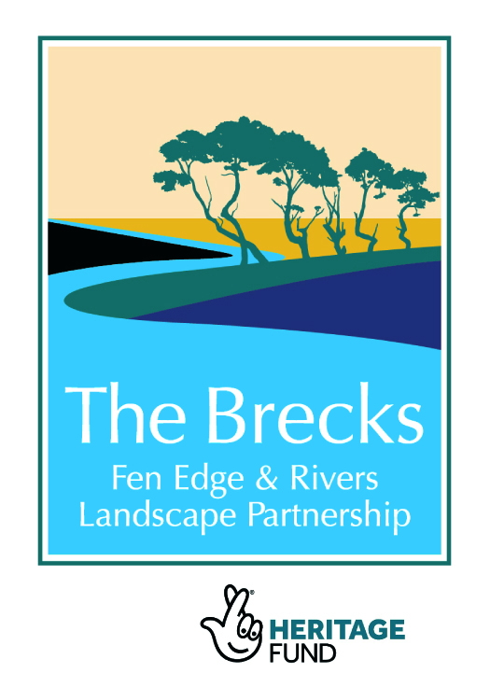
- Report of the day
- More information on workshop organisers and speakers
- Resources and guidance
__________________________________________________________

- Report of the day

The workshop was organised to bring together local landowners, land managers and local authorities with members of landowner organisation VSG, and local swimmers and those managing the project. The aim was to share useful advice and information, introduce the project, look at issues from the point of view of landowners and from swimmers, and see how the project might be able to bring us all together to work for positive outcomes around outdoor swimming and safety. It was chaired by Nick Dickson, BFER scheme manager.

Healing Waters project

Imogen Radford gave an introduction to the project, why it was developed, what we hope to do and achieve, and how it links in with the wider Brecks Fen Edge and Rivers Landscape Scheme (BFER). You can see more detail on the project here (and download the talk) https://www.imogensriverswims.co.uk/blog/os-brecks-2/, and BFER here http://www.brecks.org/BFER/.

Visitor Safety Group guidance and examples

We had two speakers from the Visitor Safety Group (VSG, https://vscg.org), Jake Williams (from Anglian Water) and Dave Liddy (Natural Resources Wales).

Jake outlined the guidance VSG is developing on outdoor swimming and visitor safety. He explained the VSG guiding principles for managing safety of visitors, avoiding restricting access, making sure visitors are aware, working with them and groups, looking at the responsibility of visitors, assessing risks and considering what the landowner might need to do to keep visitors safe. The approach will vary depending on: whether visitors are unauthorised; access is managed or unmanaged for remote or less remote areas; or whether the activity is closely managed – when visitors would expect a higher level of safety measures. He described what landowners might need to do depending on which situation applies.

Dave outlined the legal position, established by case law, which is generally you do not need to protect people against obvious dangers in the natural environment, but do need to assess and warn about unusual or unexpected sources of danger. He explained assessing the risk depending on the location, and what control measures and hazard information could be provided. This was illustrated by looking at a variety of lakes in Wales.

Landowner concerns

Andrew Blenkiron, who represents landowners on the BFER board and is Estate Director at Euston, illustrated the rivers and other waters on the estate, explained what the estate had done to adapt them for swimming for the family and for swimmers at an annual music festival. He outlined some of the concerns of landowners and those he has to consider on an estate with over 8 miles of river. Issues include considering the safety of swimmers and duty of care, liability, water quality, impact – and the many benefits of swimming.

Swimmers – benefits, types of swimmer

Tina Potter led a panel discussion with other local swimmers Emma Williams, Sean Walsh and Sean Sullivan. Each explained why they swim outdoors, what benefits it brings to them, why they enjoy it, what sort of swimmers they are, and what swimmers and landowners can do to help each other. This included benefits to mental and physical health, being close to nature and appreciating the outdoors, challenging oneself, encouraging and teaching children about the risks and joys of the water. Tina outlined the range of swimmers, most of whom take personal responsibility – some may swim solo or in pairs, some prefer loosely
organised groups, while others prefer organised venues with safety cover. Those getting into the water include athletes training for an event, families with a mixture of swimmers and non-swimmers, and some people who are not concentrating on safety. Swimmers appreciate being welcomed by landowners and are very happy to help with clearing up litter and reporting problems, and hope they can influence others who are not necessarily always so responsible.

Outdoor discussion at Lynford Water

Glyn Bradbury gave an introduction to Forestry England and Lynford Water, explaining what the organisation does and how it runs its forests, open spaces and waters for recreation, productive forestry and wildlife. He and his Ranger colleague, Nicky Russell, were able to explain aspects of the site and other sites during the discussion.

Dave Liddy and Imogen Radford led the groups and suggested issues for discussion at key points on the site. These points included responsibility of individuals and parents at popular beaches, possible risks and landowner liability, duties and actions; antisocial and risky behaviour, how responsible swimmers and the project can help; balancing conservation with swimming; opportunities to establish bathing beaches with different possible models; and what landowners might need to consider.

Other discussions, conclusions and next steps

A wide range of issues were raised in questions to speakers and in discussions. These included water quality for swimming; what responsibilities landowners have if they encourage swimming or know it is happening; impacts of swimming; what risk assessments to do and what actions to take; role of personal responsibility of those choosing to swim; how to deal with antisocial or irresponsible behaviour; how to see the most benefits from swimming.

An important part of the day were the many informal interesting discussions, and there was a chance to look at guidance and information and displays about the projects and BFER.

Participants marked places on the Brecks map where they owned or managed land and where they have swum. See a photo of the map and download a spreadsheet of the places at
https://www.imogensriverswims.co.uk/blog/os-brecks-2/landowners-and-swim-places-on-brecks-map/

The concluding session of the day was a chance to plan to discuss the issues raised further, how to balance concerns and benefits, to share guidance and resources, and to keep in touch and work together as the project develops.

There is a short report of the workshop here https://www.imogensriverswims.co.uk/blog/os-brecks-2/11-march-2020-landowners-workshop/

- More information on workshop organisers and speakers:

The Brecks Fen Edge and Rivers Landscape Partnership Scheme (BFER) is a group of government and non-government agencies and interest groups working together to deliver a National Lottery Heritage Funded Landscape Partnership scheme. The Scheme is a collection of 24 innovative projects focusing on water related heritage & landscape, to be delivered by a wide range of partners. http://www.brecks.org/BFER/; @TheBrecksLP.

The Healing Waters project, part of the BFER scheme, will engage people in outdoor watery activities with training to enjoy the waters safely and with care for the environment, and it will map and consider establishing and publicising suitable places for swimming or for other recreational uses of the rivers. https://www.imogensriverswims.co.uk/blog/os-brecks-2/healing-waters-project-outline/.

The Visitor Safety Group (VSG) is a landowner organisation that seeks to balance access for visitors with safety but with minimal barriers (https://vscg.org; https://vscg.org/guiding-principles/). VSG members include many large and small landowners and safety organisations that have a wealth of experience in the issues raised by visitors to their land. VSG has published the revised edition of their invaluable guide, Managing Visitor Safety in the Countryside.

Forestry England (FE) manage the nation's forests sustainably to keep our public forests and landscapes as special places for nature that people can enjoy and businesses can thrive in (https://www.forestryengland.uk/about-us). Thetford Forest is the UK’s largest man made lowland forest, a richly varied landscape of forest and heath that includes river valleys and the lakes at Lynford Water. Santon Downham is a forestry village that hosts the regional FC/FE offices. The Forestry Commission (FC) is a member of the VSG management board.

The Outdoor Swimming Society (OSS) was established in 2006 to pioneer outdoor swimming in rivers, lakes, lido and seas, and now has 100,000 members. It has spearheaded significant cultural change in the way outdoor swimming is viewed and the number of people who take part in it. The OSS Inland Access Group shares expertise between members in their work to establish more free swimming areas in UK and to protect those that exist. Together with OSS lawyer Nathan Wilmot and Creative Director Kate Rew, the group published A Guide to Setting up Inland Bathing Areas in 2018 (free to download from https://www.outdoorswimmingsociety.com/access-all-areas/).
_____

- Resources and guidance

Visitor Safety Group guidance, 'Managing Visitor Safety in the Countryside: Principles and Practice', new edition available for £20 from:
https://www.ypdbooks.com/misc/2089-managing-visitor-safety-in-the-countryside-principles-and-practice-YPD02361.html

Chapter 2, 'Guiding Principles' explaining how to balance visitor access and safety (the earlier edition of this can be read on the VSG website, http://vscg.org/guiding-principles/).
An electronic version of the full publication is available to VSG members via their organisation's key VSG contact. Find out about VSG and how to join https://vscg.org/.

Outdoor Swimming Society guidance for landowners, 'Inland Bathing Areas: a Guide to Setting up Inland Bathing Areas in the UK', is explained and PDF is available for download, https://www.outdoorswimmingsociety.com/access-all-areas/

RoSPA guidance, ‘Managing safety at inland waters guidance’ January 2019, has detailed advice on the law and practical guidance for landowners using case studies. Sign up in box on their website (document link sent by email to download free PDF), https://www.rospa.com/leisure-safety/water/inland/

Risks to health and safety of outdoor swimming, and how to mitigate them, in general and in the Healing Waters project. Note, Imogen Radford, project lead.

Advice to swimmers on safety

There is an enormous amount of guidance to swimmers on how to swim safely in all conditions, focusing on them assessing risks for themselves. This article on my website links to many sources, https://www.imogensriverswims.co.uk/blog/issues/swim-safety/, and the Outdoor Swimming Society has a wide range of articles advising on all aspects: https://www.outdoorswimmingsociety.com/category/survive/

Bathing water quality

SH2OUT guidance (2017), which focuses on venues and events (rather than waters in general on land you own or manage), can be downloaded from http://bit.ly/SHOUTWQ2017.

On my website are links to guidance aimed at swimmers on this subject (which are also below): https://www.imogensriverswims.co.uk/blog/issues/bathing-water-quality/.

Outdoor Swimming Society guidance for swimmers – a pragmatic way to judge if it is clean to swim: https://www.outdoorswimmingsociety.com/is-it-clean/; more detailed guidance on Weil's disease https://www.outdoorswimmingsociety.com/understanding-weils-disease/.
These are supplemented by the Rivers Trust interactive map showing water treatment works and the flow direction of rivers, enabling swimmers to choose not to swim downstream of them after heavy rain, linked to from this page on their website: https://www.theriverstrust.org/2019/09/22/world-rivers-day-rivers-fit-to-swim-in/; and advice to swimmers on blue green algae from the Lake District: https://www.swimthelakes.co.uk/12915/blue-green-algae-and-swimming/

An explanation of the Bathing Water Directive – what it does and why it matters https://www.outdoorswimmingsociety.com/designated-bathing-waters-explained/; and a discussion of the pros and cons for local swim groups in campaigning for a place to be designated https://www.outdoorswimmingsociety.com/should-swimmers-seek-bathing-water-designation-for-local-swim-spots/

An issue raised at the workshop was the impact on the environment of swimming and associated behaviour, and the Outdoor Swimming Society has a group working on this now. They have already looked at sunscreen:
https://www.outdoorswimmingsociety.com/ocean-friendly-river-friendly-sunscreens/

Report, info and resources, Imogen Radford, March 2020

