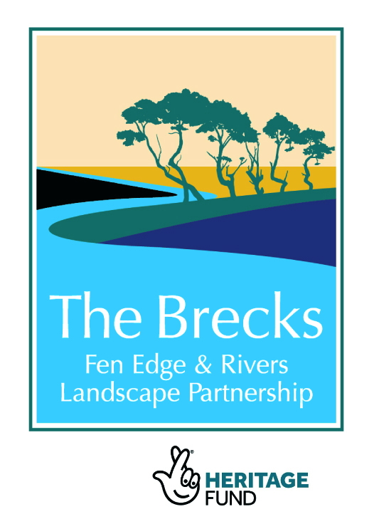
TALES FROM THE RIVER TRAINING BEGINS 7 JULY 2021

The Tales from the River project aims to discover and celebrate Brecks
swimming and outdoor recreation heritage. It will train and involve
volunteers in gathering history, stories and folklore about recreation
in/on/by the Brecks rivers and other waters. The project is part of
The Brecks Fen Edge & Rivers Landscape Partnership Scheme
(BFER), supported by the National Lottery Heritage Fund.

FIRST TRAINING SESSION

Wednesday 7 July, 1230-1630 (arrive 12 for tea and coffee)
Santon Downham Community Centre, Marks Lane, IP27 0TW

Tales from the River: Doing research and discovering the archives at Norfolk Record Office
The trainer will explain how to access the archives and do your own research, and will illustrate this with examples of relevant documents/maps/material from the collection.
We will follow the training with a discussion on how volunteers can take the project forward and how we can organise doing some research and gather materials and stories on swimming and other river recreation.

No previous experience is needed. This is an opportunity to develop research skills and to put them into practice to delve into the rich history and wealth of memories of watery outdoor activities in the Brecks area.
If you already have some experience in doing research or oral history then come and explore this fascinating area of history.
Come and be part of a team of volunteers to discover and gather some interesting stories and material.

Training will be conducted in line with Covid 19 safety procedures, and the spacious venue allows appropriate spacing and other measures.

Volunteers can work flexibly, giving as much or as little time as they can spare to do research and material gathering. Some of this can be done from home, using books or online resources.

Volunteers can claim travelling and essential expenses and there will be support from the project including hold further discussion and training sessions if needed.

We will need some help in finding people who have any stories, memories, folklore, old maps, photos or films about outdoor swimming and other watery recreation in the Brecks, and would be willing to be interviewed about these or to tell us about them.

More details about the project and later training sessions over the page.

Please contact me

- to attend training session/s
- to find out more
- to get involved

Imogen Radford imogen36@googlemail.com
MORE ABOUT THE PROJECT – OUTPUTS, REASONS, AIMS

Presenting the findings
We will continue to gather materials into 2022, before compiling and presenting them in a variety of ways, including exhibition, video, website pieces, and to enrich the county archives. Heritage information will inform the Healing Waters river survey and map, and will appear together with safety advice at key swimming spots. Throughout we can share information that will be of interest with other projects, and within this project interesting stories, materials and oral history extracts will be made available to the Youth strand of the project, to be compiled into an exhibition and video.

Liaison with other projects
Projects that might be of interest and would be particularly relevant for liaison: the survey and mapping of the rivers element of the Healing Waters project (which I am also leading on, https://www.imogensriverswims.co.uk/blog/os-brecks-2/healing-waters-project-outline/); and the project looking into the history of trade on the rivers, Industrious Rivers (organised by the Breckland Society, https://brecks.org/bfer/projects/under-the-surface-discovering-heritage/2-3-industrious-rivers/), and perhaps some of the other BFER projects (http://brecks.org/BFER/projects/)

Reasons for the project
The rivers and other water bodies have always been very important in the Brecks, a very dry area with hot summers. There is a rich tradition of swimming and other water-based recreation across the generations, and we hope to uncover many memories, old photos and films, stories and folklore about these activities.

Although young people have carried on the tradition of flocking to local swimming spots in the rivers in the summer, and outdoor or wild swimming has become very popular in the last few years, many people have lost the knowledge and confidence to do so, and myths and fears – some exaggerated – have taken their place. The places people go to swim and enjoy the water have always been those to which they have access, often associated with footpaths and bridleways, places of baptism, ferries, mills and old ponds.

We should celebrate this heritage and– in conjunction with other projects such as Healing Waters – revive and to continue into the future our connection with the water in the Breckland landscape.

Purpose and aims
- To train people in archive research, oral history interviewing and related skills
- To uncover the heritage of swimming and other river-based recreation in the past and present, by gathering memories, stories and folklore, photos and film
- To understand and celebrate the heritage and traditions of swimming and other watery recreation
- To connect us to this important aspect of the Breckland landscape
- To inform the Healing Waters project on the places, heritage and attitudes
- To provide material for the youth strand of the project
- To present material in various ways including exhibition, video, website, archives

Training and discussion programme 2021

Wednesday 7 July, 1230-1630  – Santon Downham | Tales from the River: doing research and intro to Norfolk Record Office, followed by a discussion on taking the project forward
Friday 7 September, 1000-1600  – venue to be decided | Tales from the River: intro to Oral History collecting
Wednesday 15 or 22 September  – possibly 1230-1630 | Tales from the River: doing research and intro to Suffolk Record Office, Bury St Edmunds
September/October ?  – date and time to be arranged | Tales from the River: tour of Norfolk Record Office  Norwich

