Visitor Safety Group guidance, available to members/subscribers from https://www.visitorsafety.group/topic-guidance/open-water-swimming/

Topic Guidance – Open Water Swimming
Lakes, rivers, reservoirs, canals and coasts; all appear irresistible to increasing numbers of people looking for somewhere to swim in the open air. But what are your responsibilities, if any, for ensuring their safety?
You might want to allow swimming, but not promote it, and have no one on-site to manage visitors.
Elsewhere it could make sense to promote swimming in zones where depth and shelving pose lesser risks, and perhaps you can provide lifeguards.
How far is it reasonable to expect swimmers to act responsibly and take care for their own safety?
You might think that banning swimming would make life easier. But what if people ignore your signs? Does fencing designed to keep swimmers away, simply make rescue impossible?
This guidance provides a framework for risk assessment and provides signposts to encourage responsible open water swimming.

Open Water Swimming - Introduction
Swimming has long been a popular recreational fitness activity in the UK, with Sport England rating it as the fourth most popular activity in the UK in 2017 (Figure 1).
The number of people taking part in open water swimming in the UK has increased rapidly in the last decade. Figures from the Active Lives Survey show that 93,500 people now swim in open water every week. The growth seems to be accelerating with survey figures showing participation levels in Open Water Swimming (defined in this guidance as any swimming that is not in a swimming pool) doubling in the last decade.
Numbers have also increased through the emergence of commercial operators and the increasing number of open water races and events – many of which cater for all abilities, lowering the barrier for people to enter into rivers, lochs, lakes or the sea. Restrictions in the use of indoor pools during the COVID 19 pandemic further increased numbers.
As well as appealing to those chasing an adrenaline rush, outdoor swimming is also luring existing swimmers looking for “something different” – often after growing bored with, or being denied use of, their regular swimming pool experience. Outdoor swimming offers a physical challenge, novelty and the unknown. Open water swimmers experience a sense of accomplishment, achievement, and fulfilment on both a personal and group `level. (Muranovova, Andrea 2013) Open water swimming provides significant health & wellbeing benefits. It also serves to connect participants with the outdoors and may help generate respect for the environment.
In addition to greater numbers enjoying swimming outdoors in summer, more people are taking open water dips all year round.
In response to the growth in swimmers in the outdoors, landowners need to consider the risks and assess what mitigation, if any, is appropriate on their property.
Of course, there is also the continuing need to consider the risks to people jumping into open water simply to cool off on a hot day, and those ending up in water by accident.
Figure 1:
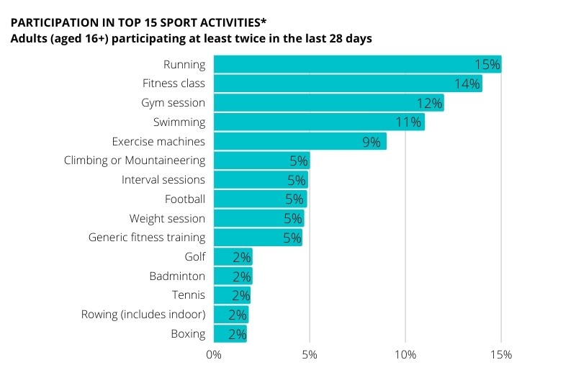
Source: Sport England ‘Active Lives Survey, Table 7, 12th October 2017 (data labels rounded to 1%)
Figure 2: Management of recognised pathways to open water access
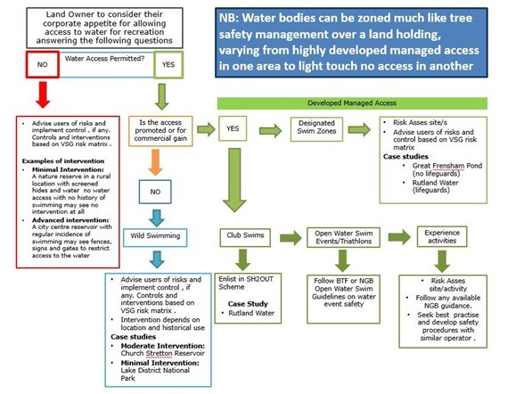

Open Water Swimming – Legal Considerations
While there is to date no legal definition or case law defining ‘safe access’ to open water, the RoSPA ‘Managing Safety at Inland Waters’ publication offers the following guidance as to how the Health and Safety Executive mightconsider lliability for prosecution:
Death or serious injury to a member of the public in open water: The Health and Safety Executive guidance note to inspectors considering enforcement of duties under Section 3 of the HSWA.
The examples are written as a series of issues that tend towards or tend away from investigation. Using the examples should not simply be a matter of adding up the number of factors on each side and seeing which side has the greater number. It is quite possible that one factor alone may outweigh a number of other factors which tend in the opposite direction. Each decision will need to be made on a case-by-case basis and turn on its own facts. Throughout the examples, the words ‘serious injury’ are used – for the purposes of this guidance – this means injuries that are so serious that death might have resulted.
Some factors tending towards investigation
- There was a clear undertaking or employer with duties under the HSWA; and
- Swimming and/or water activity was actively encouraged; or
- The affected person was a child or other vulnerable person cared for as part of a work activity; or
- There was evidence of hazards that are uncontrolled or unmanaged (this includes hazards the duty holder was aware of and those they should have been aware of had they carried out a suitable and sufficient risk assessment); or
- The activity and the competence of the affected person required a level of training and/or supervision and that training/supervision was either not provided or was inadequate.
Some factors tending away from investigation
- There was no duty holder or undertaking (or it is difficult to define duties) for example a beach or other natural feature where the public have open access; or
- Swimming and/or water access was either not encouraged or was actively discouraged; or
- The affected person was not involved in a supervised activity under the control of a duty holder such as a school or club; or
- Evidence suggests that the affected person (or their parent or guardian) was able to make a risk-based decision and took a risk they were made aware of or should have been aware of and causation was due to individual choice or error; or
- The nature of water and underwater hazards was made clear through unambiguous signage; or
- Supervision and training provided to the affected person were appropriate.
Partnership
Working with responsible swimming groups, such as OSS, will help to promote understanding, resolve conflicts and further responsible access by swimmers.
Open Water Access Pathways: Considerations for Landowners
VSG recognises the following ways people access open water:
- Unauthorised Access
- Entering a water body where the landowner does not allow access.
- Unmanaged Access (can be classed as wild swimming)
- Where a landowner does not forbid access and allows or accepts that users swim at their own risk. Landowner takes no action to warn user of the danger, for example at upland lakes, some rivers and canals in rural areas or remote beaches. It would be expected that visitors carry a high level of skill, as they are visiting undeveloped or remote and wild areas with no safety intervention.
- Managed Access
- This could be
- designated swim zones
- lifeguarded swim zones
- triathlons/swim events or club swims in open water
- experience activities
Risk assessment would be expected with safety intervention reflecting the location of the activity and the number, age and experience of the swimmers.
- Responsible Access
- Under Scottish Outdoor Access Legislation people have a right to access open water for recreation. When exercising this right, swimmers are required to act reasonably and to take responsibility for their own actions. Where possible, landowners should indicate where people can best gain access to a river or loch.
Of course, the principle of responsible access is applicable everywhere. Swimmers should be aware of their responsibilities to the environment, landowners and other users as well as exercising care for their own safety. Landowners might need to warn of unusual risks and consider zoning, for example to enhance swimmers’ safety or to protect wildlife.
Zoning
It is recognised that large and complex water bodies may have differing levels of access permissions in different areas. Consequently, landowners may wish to ‘zone’ their water body (in a similar way to zoning on land) with interventions based on the relative development of individual areas and the level of skill of visitors.
For example: a visitor centre overlooking a lake where water access is prohibited is likely to attract a wide range of visitors. As a result, interventions to prevent access at the visitor centre itself are likely to be higher. In contrast, the remote side of the lake may be more challenging to access and relatively undeveloped. Therefore, the landowner may decide not to introduce controls to prevent water access, away from the visitor centre.
When managing open water access, landowners should consider which pathways to open water swimming are applicable and their corporate appetite to risk. When carrying out risk assessments the landowner should refer to VSG Guiding Principles and the VSG Risk Control Spectrum to help determine the level of intervention required at their specific water body. The RoSPA publication ‘Managing Safety at Inland Waters’.

OPEN WATER ACCESS PATHWAYS
Unauthorised Access
Landowners should take action, as appropriate, to communicate that open water swimming is not allowed. Other risk controls may be required, dependent upon the site’s location along the Risk Control Spectrum.
Examples of intervention
- Minimal Intervention: A nature reserve in a rural location with screened hides and water, no water access and no history of swimming may need no intervention at all.
- Advanced intervention: A city centre reservoir with regular incidences of swimming may need signs and require fences or gates that restrict access to the water.

1. Designated Swim Zones
In the absence of set rules and guidance for managing designated swim zones, landowners should read the RoSPA ‘Managing Safety at Inland Waters’ publication and adopt an approach best suited to their circumstances. Landowners operating designated swim zones should ensure:
- the zone is risk assessed, clearly defined and, as far as practicable, free from hazards
- the management of the designated swim zone is communicated with the users
- all risks are clearly communicated to the user e.g.
- water depth
- current
- weeds
- substrate material
- presence or absence of lifesaving equipment
- presence or absence of lifeguards
- presence or absence of external risks such as boats, animals, anglers
- water quality
- and other information such as closing times, first aid points and toilets
Examples of intervention
- Frensham Great Pond (no lifeguards)
A non-lifeguarded facility may be acceptable, following risk assessment. These types of facilities often, but not exclusively, have a maximum water depth of 1.5m (4 foot 11 inches) as this is seen as less of a risk than deeper water.
Frensham Great Pond is a natural lake situated between Farnham and Hindhead, Surrey. The area is made up of a large area of heathland, together with some coniferous and mixed woodland. It is owned by Waverley Borough Council, which allows managed non-lifeguarded swimming through the use of signage giving safety advice, the latest water-quality readings as a registered bathing area, and restricting the maximum depth to 1.4m. Due to its limited area and popularity with families it is really only suitable for recreational swimmers.
- Rutland Water (lifeguards)
With no official inland bathing waters in the English Midlands, the Outdoor Swimming Society (OSS) identified an obvious demand for such a facility. In 2009, Robert Aspey, the newly appointed OSS Inland Access Officer, approached several public and private landowners with the idea of creating an inland bathing beach similar to those he had discovered while travelling in Central Europe. These landowners proved to be very risk averse and nervous, so progress was slow.
However, in the autumn of 2010 he approached the visitor operations manager at Anglian Water Services with this idea, and was well received. Then, with the backing of Anglian Water Services, Swim England, and Leicestershire & Rutland Sport, he put together a joint proposal for a bathing beach along the north-east shore of Rutland Water. Rutland Water is situated in a rural part of the East Midlands. As one of the driest and warmest parts of England in summer, and with several large cities within a 40-mile driving distance, it is an ideal location.
In 2011, to prove there was a real demand for such a facility, Anglian Water Services consulted the local population and found overwhelming support for a bathing beach. This then became part of the development strategy for Rutland Water. Several organisations including the RLSS worked together producing risk assessments, operating procedures, getting approvals from the Anglian Water Services board, and organising lifeguarding.
From an environmental perspective approval was required from the head of water quality and the head of water treatment at Anglian Water Services, and also from Natural England (as Rutland Water is an SSSI site). All these approvals were then granted. Anglian Water Services undertook a water-quality assessment which did not throw up any problems regarding people swimming in the water. The area designated for the beach was cleared of overgrowth, and sand was delivered to form a beach area beside the water.
The bathing area was clearly defined with floatation buoys linked by a rope and secured firmly to the bank side at either end. It covers an area 140m long by 20m wide measured from the shoreline. The line of buoys can be moved to suit varying water levels. There is a gradual slope out from the beach to a maximum depth of about 6ft (1.83m). The lifeguards are beach trained and it was determined no demarcation was needed between the paddling and swimming areas. This has worked well in practice.
2. Triathlons/Swim Events or Club Swims in open Water
Often these are commercial events or experience activities, but they could also be non-commercial. Typically, there will be a manger or coordinator with responsibility for the event. Owing to the popularity of open water events in the UK, the safety guidelines and procedures around water temperature, quality and management are now well-defined. Landowners should follow the guidance in place from the British Triathlon Federation (British Triathlon Federation, Open Water Swimming Safety Guide), or a suitable accreditation scheme:
- Beyond Swim
- Open Water Swimming Safety Accreditation Scheme run by British Triathlon Federation and Royal Life Saving Society UK).

3. Experience activities
These will almost certainly be commercially run and as such should carry a high level of safety management. Operators and landowners should:
- risk assess site and activity
- follow any available National Governing Body guidance
- develop best practice and safety procedures with similar operators

Typically defined as wild swimming in bodies of water in Scotland, using access rights under the Scottish Outdoor Access Code. Formal management of the water body may exist (for example, reservoirs and canals) and swimming may be discouraged but not prohibited.
Examples of intervention:
- Minimal intervention: Landowner indicates where people can best take access to a water body
- Advanced intervention: Advise swimmers of the risks and provide safety advice. Further advice available from National Water Safety Forum

OPEN WATER ACCESS PATHWAYS
Unmanaged Permitted Access
Typically defined as wild swimming, in natural bodies of water, often in rural landscapes, where no formal management of the water body exists and where swimming is not prohibited. For example, a walker swimming in an upland lake or a river would be wild swimming. Beach goers swimming outside of lifeguarded areas would also be considered wild swimmers. The RoSPA publication Managing Safety at Inland Water Sites provides guidance on how to manage the risks associated with wild swimming.
Examples of intervention
- Minimal Intervention: The lake District National Park
Wild swimming in most of the tarns, lakes and rivers of the Lake District has been practiced for generations with no specific restrictions. Due to the increasing popularity of wild swimming since 2000, the park authorities met with wild swimming groups in 2013 to agree on the best way of encouraging safety amongst all the users of the lakes (canoeing, sailing, boating, and swimming). This resulted in the adoption of official wild swimming guidance – a model of good practice that could be used by other landowners.
As well as online guidance, the park authorities issue leaflets and have installed signs to encourage safe wild swimming in the park. They now positively encourage wild swimming, stating ‘Swimming in tarns, lakes and rivers is great fun; however, it’s important to stay safe’.
- Advanced intervention: Church Stretton Reservoir
The National Trust (NT) have a reservoir on their Carding Mill Valley site in Shropshire where mainly children used to swim in the holidays. The NT initially put up signs prohibiting swimming, and NT wardens kept telling the children not to swim, but as soon as the wardens left, the children would go back in the water.
The NT realised they were not going to be able to stop the children swimming, and they did not want to stop them having fun. In a ground-breaking move in around 2010, they carried out a site risk assessment, and installed Wild Swimming Safety signs, throw lines, and buoys indicating where the depth exceeds 1.4m.
This is now an extremely popular free wild swimming reservoir that draws more people to the site, where they spend money on car parking and the café. This is an excellent model of good practice on how to manage wild swimming.
The Trust now promote wild swimming in the reservoir as a top-ten activity!

On Thursday 8th July 2021 VSG launched the new guidance on open water swimming. This webinar was timely given the rise in water-based recreational activities such as open water swimming and other water-based recreational activities. It follows our recent theme of understanding the ‘new visitor’ and the need to cater for inexperienced novices. There was also discussion on how the Guidance dovetails with existing Codes and Guidance and how we can work together to ensure the messages conveyed are effective.
This webinar looked at at:
- Why is the new VSG ‘Open Water Swimming Access Guidance’ needed?
Jeanette Roberts, Head of Health and Safety, Scottish Canals
- Open Water Swimming Access Guidance: content and principles
Will Kirstein, Park Manager, Anglian Water
- Outdoor Swimmers Code and Swimming without a Trace
Imogen Radford, Inland Access Officer, Outdoor Swimming Society
- Respect the Water framework
Carlene McAvoy, Leisure Safety Manager, RoSPA and National Water Safety Forum
There was also an opportunity for members to take part in deeper discussion in Breakout Rooms.
Watch Back: Open Water Swimming Safety Webinar
Click here to access recordings and resources from the webinar – 8th July 2021
OPEN WATER SWIMMING GUIDANCE
- References and useful papers

- Evaluating the active sports tourist experience of open water swimmers – Muranovova, Andrea (2013) Master’s thesis (MPhil), Manchester Metropolitan University
- Sport England Active Lives Survey
- House of Commons Briefing Paper Number CBP 8181, 14 December 2017
- RoSPA: Managing Safety at Inland Water Sites
- British Triathlon: Open Water Swimming Safety Guide for Multi-Sport Events
- Outdoor Swimming Society: Access All Areas (includes a number of the case studies used)
- Outdoor Swimming Society: The Outdoor Swimmer’s Code
- National Water Safety Forum Open water swimming advice
- Royal Life Saving Society: is a provider of water safety and rescue services, at a wide range of open water events

Saved Feb 2024
Visitor Safety Group guidance, available to members/subscribers from https://www.visitorsafety.group/topic-guidance/open-water-swimming/

